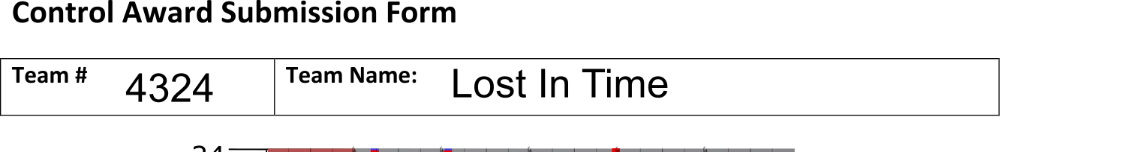

Autonomous objectives:

Currently to park in the floor goal, out of the way of our partner team.

Sensors used:

A Single-Pull Single-Throw Switch -

Used to tell the robot which side of the field it is on, set to red or blue before the start of a match. This is used in the code to reflect certain actions like turning that vary depending on which side of the field the robot is on.

We plan on implementing an advanced heading sensor developed for FTC robots, motor encoders for measuring distance, and a light sensor like a color sensor or a camera.

Key algorithms:

We created our own ‘mini-programming language’ for easily creating and modifying many different autonomous variations, called event configs. The three main events our code currently has are: a move event (moves forward/backward), a turn event (turns left/right) and a pause event, which all are time-based. This is why we have not added any autonomous diagrams below.

Driver controlled enhancements:

Engineering notebook references:

See dedicated software notebook.

Autonomous program diagrams:

See Key Algorithms section above.